Day 1

Making a demo page

<h1>HELLO WORLD</h1>

<P>HI MY NAME IS ASTHA AND I HAVE STARTED LEARNING HTML OR THE HYPERTEXT MARKUP LANGUAGE TODAY.</P>

astha kumari@DESKTOP-OHHL92I MINGW64 ~

$ pwd

/c/Users/astha kumari

astha kumari@DESKTOP-OHHL92I MINGW64 ~

$ cd c://

astha kumari@DESKTOP-OHHL92I MINGW64 /c

$ ls

'$Recycle.Bin'/ dell/ Drivers/ FIOD.manifest OneDriveTemp/ 'Program Files'/ python_code/ 'System Volume Information'/

'$WinREAgent'/ dell.sdr DumpStack.log hiberfil.sys pagefile.sys 'Program Files (x86)'/ Recovery/ Users/

Apps/ 'Documents and Settings'@ DumpStack.log.tmp Intel/ PerfLogs/ ProgramData/ swapfile.sys Windows/

astha kumari@DESKTOP-OHHL92I MINGW64 /c

$ mkdir HTML_CSS

astha kumari@DESKTOP-OHHL92I MINGW64 /c

$ ls

'$Recycle.Bin'/ dell/ Drivers/ FIOD.manifest Intel/ PerfLogs/ ProgramData/ swapfile.sys Windows/

'$WinREAgent'/ dell.sdr DumpStack.log hiberfil.sys OneDriveTemp/ 'Program Files'/ python_code/ 'System Volume Information'/

Apps/ 'Documents and Settings'@ DumpStack.log.tmp HTML_CSS/ pagefile.sys 'Program Files (x86)'/ Recovery/ Users/

astha kumari@DESKTOP-OHHL92I MINGW64 /c

$ cd HTML_CSS

astha kumari@DESKTOP-OHHL92I MINGW64 /c/HTML_CSS

$ LS

astha kumari@DESKTOP-OHHL92I MINGW64 /c/HTML_CSS

$ touch index.html

astha kumari@DESKTOP-OHHL92I MINGW64 /c/HTML_CSS

$ ls

index.html

astha kumari@DESKTOP-OHHL92I MINGW64 /c/HTML_CSS

$ code index.html

astha kumari@DESKTOP-OHHL92I MINGW64 /c/HTML_CSS

$

Resulted webpage

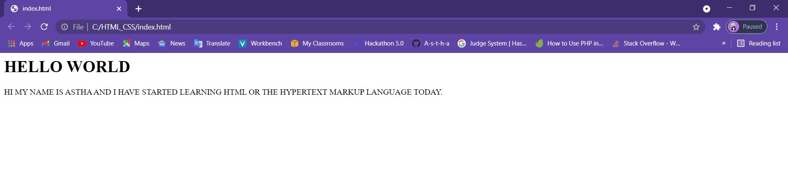

Task 2 : used live server extension in vs code

Task 3 : learnt about Emmet in html to to code faster

Below I am providing link for the cheat sheet for emmet if you are using vs code

<https://docs.emmet.io/cheat-sheet/>

All unknown abbreviations will be transformed to tag, e.g. foo → <foo></foo>.

!

Alias of html:5

<!DOCTYPE html> <html lang="en"> <head> <meta charset="UTF-8" /> <title>Document</title> </head> <body> </body> </html>

They are the small snippets of program are prepared for us

Day 2

Task 1: creating a basic demo webpage

<!DOCTYPE html>

<html lang="en">

<head>

    <meta charset="UTF-8">

    <meta http-equiv="X-UA-Compatible" content="IE=edge">

    <meta name="viewport" content="width=device-width, initial-scale=1.0">

    <title> MY FISRT WEB PAGE</title>

    <h1>hello pepole</h1>

    <h2> This is Astha Kumar </h2>

    <p> Hi this is astha kumari and I am a cloud student in UPES with specialisation in cloud computing and virtualisation.</p>

</head>

<body>

</body>

</html>

